RTOS平台DVP/I2C接口软件开发资料说明

DVP/I2C Interface Development Instructions

该版本的SDK主要针对Tiny系列和Mini256系列在STM32或者其他RTOS平台下通过DVP接口进行图像/温度数据传输和I2C接口进行命令控制。本SDK的开发平台为正点原子的STM32F767开发板，为方便用户开发，全部源码均开放，用户可基于该平台的例程自行设计转接板或者在其他RTOS或者裸机平台中开发本产品。
This version of SDK is mainly for Tiny series and Mini256 series on STM32 or other RTOS platform through DVP interface for image/temperature data transmission and I2C interface for command control. The development platform of this SDK is the STM32F767 development board of alientek. In order to facilitate the development of users, all the source code is open. Users can design the conversion board by themselves based on the routines of this platform or develop this product in other RTOS or bare computer platforms.

SDK工程目录介绍The SDK components
本SDK的例程是通过正点原子的OV5640的摄像头官方例程进行修改而成，因此保留了主体的工程结构，相关的文件目录介绍如下：
The routines of this SDK are modified by the official routines of OV5640 camera of The Atom, so the main engineering structure is retained. The relevant files and directories are introduced as follows:
- CORE:芯片相关的启动文件和相关的头文件。
CORE: chip related startup files and related header files.
- HALLIB：芯片外设的固件驱动库，src存放的是固件库的.c文件，Inc存放的是固件库的.h文件，每个外设对应一个.c文件和一个.h文件。
HALLIB: the firmware driver library of the chip peripherals. src stores the. c file of the firmware library, Inc stores the. h file of the firmware library, and each peripheral corresponds to a. c file and a. h file.
- HARDWARE：具体硬件操作的进一步封装。
HARDWARE: Further encapsulates specific hardware operations.
- FATFS: fatfs文件系统相关的文件，用于固件升级。
FATFS: File related to fatfs file system, used for firmware upgrade.
- MALLOC:内存管理相关的文件，用于固件升级。
MALLOC: memory management-related file used for firmware upgrade.
- SYSTEM:公用的系统、延时和串口函数。
SYSTEM: Common system, delay, and serial port functions.
- USER：主要是main.c用于用户自定义主函数的功能实现。
USER: Mainly main.c is used for the function realization of user-defined main functions.
- USMART: 串口调试互交组件。
USMART: Serial port debugging interchangeable components.
- VDCMD:模组相关的参数读写接口实现、命令解析以及底层通信接口适配等。
VDCMD: module related parameters read and write interface implementation, command parsing and underlying communication interface adaptation.
- OTHER:其他SDK相关的功能实现，包括指令发送、环境变量修正和固件升级功能。
OTHER: other SDK-related functions, including instruction sending, ambient variable modification, and firmware upgrade.

使用前提Premise
- 客户的开发板或者目标平台芯片支持I2C接口和DVP接口。
Customer's development board or platform supports I2C&DVP interface
- 客户开发平台最好能支持串口调试。(非必要)
Customer development platform should support serial port debugging. (Not necessary)

DVP接口说明SPI Interface Description
Tiny1C产品支持DVP接口图像/温度数据输出。

DVP接口介绍DVP interface description
DVP（Digital Video Port） 是传统的sensor输出接口，采用并行输出方式，d数据位宽有8bit、10bit、12bit、16bit，是CMOS电平信号（重点是非差分信号），PCLK最大速率为96MHz，接口如下图：
DVP (Digital Video Port) is a traditional sensor output interface, which adopts parallel output mode. The data bit width is 8bit, 10bit, 12bit and 16bit, and it is CMOS level signal (non-differential signal is the focus). The maximum speed of PCLK is 96MHz.

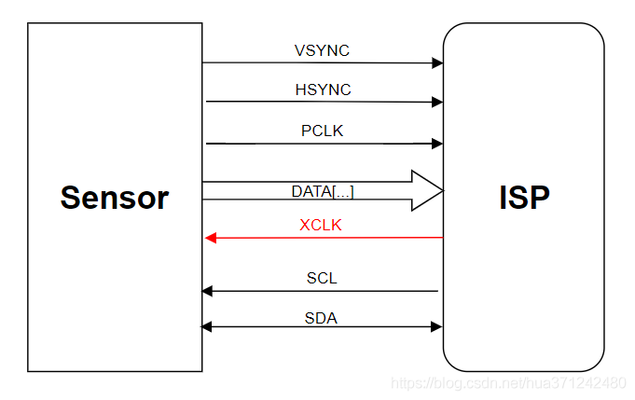
DVP接口引脚说明如下：
PCLK：pixel clock ,像素时钟，每个时钟对应一个像素数据；对于tiny1C来说，一个像素需要两个时钟信号。产品的YUYV/Y16/Y14/Y10格式均由两个字节表示一个像素。且均是高位有效。
PCLK：pixel clock. Each clock corresponds to a pixel data; For Tiny&Mini256, one pixel requires two clock signals. The YUYV/Y16/Y14/Y10 formats of the product all consist of two bytes representing a pixel. And both of them are high bits effective.
HSYNC：horizonal synchronization，行同步信号
VSYNC：vertical synchronization，帧同步信号；
DATA：像素数据，视频数据，具体位宽要看ISP是否支持；Tiny&Mini256仅支持8位数据位宽。每个像素（16bit）需分两个时钟传输，先传输高8位，再传输低8位。
DATA: pixel data/video data. The specific bit width depends on whether ISP supports it. Tiny&Mini256 supports only 8 data bits，Each pixel (16bit) needs to be transmitted in two clocks, first the high 8 bits and then the low 8 bits.
XCLK：或者MCLK，ISP芯片输出给驱动sensor的时钟；(Tiny&Mini256不需要此引脚)
XCLK: or MCLK, the clock the ISP chip outputs to the driver sensor; (Tiny&Mini256 does not require this pin)
SCL，SDA：IIC用来读写sensor的寄存器，配置sensor。
SCL, SDA: IIC is used to read and write the register of the sensor and configure the sensor.

产品相关的DVP配置Product-specific DVP configuration
Tiny&Mini256的dvp配置如下,Tiny&Mini256的DVP同步方式采用的是硬件同步方式，即外同步方式。
Tiny&Mini256 DVP configuration is as follows, Tiny&Mini256 DVP synchronization adopts hardware synchronization, that is, external synchronization.
- PixClk极性：下降沿有效
PixClk polarity: effective down edge
- 行同步极性：低电平有效
Line synchronous polarity: valid at low level
- 帧同步极性：高电平有效
Frame synchronization polarity: valid at high level
- 数据位宽：8位数据
Data bit width: 8 bits
- PixClk大小：12MHz
PixClk size: 12MHz
说明Description：
- 对于主控端而言，PixClk极性是下降沿有效，即下降沿开始采样数据。但对于模组而言，上升沿有效，即上升沿发送数据。
For the master terminal, PixClk polarity is effective on the falling edge, that is, the falling edge begins to sample data. But for modules, the rising edge is valid, that is, the rising edge sends data.
- 对于主控端而言，行同步信号为低电平，即低电平表示一行新数据传输完成，采样数据时HSYNC信号为高电平。
For the master terminal, the line synchronization signal is low level, that is, low level means that a new line of data is transmitted, and HSYNC signal is high level when the data is sampled.
- 对于主控端而言，帧同步信号为高电平，即高电平表示一帧新数据传输完成，采样数据时VSYNC信号为低电平。
For the master terminal, the frame synchronization signal is high level, that is, high level means that a new frame data transmission is completed, and VSYNC signal is low level when the data is sampled.
相关的时序图如下：The relevant sequence diagram is as follows
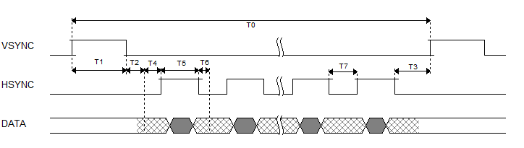
One frame timing figure
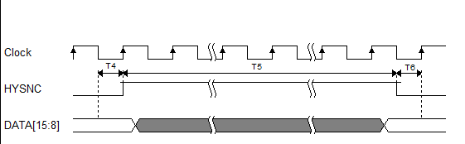
One line timing figure

mode | frame rate | timing
256*192 | 25fps | Clock: 12MHz
 |  | T0: 479776
 |  | T1: 8272
 |  | T2: 33088
 |  | T3: 42916
 |  | T4: 129
 |  | T5: 512
 |  | T6: 1427
 |  | T7: 1556
256*384 | 25fps | Clock: 12MHz
 |  | T0: 479968
 |  | T1: 4528
 |  | T2: 18112
 |  | T3: 23260
 |  | T4: 129
 |  | T5: 512
 |  | T6: 491
 |  | T7: 620

DMA模块参数设置DMA module parameter Settings
DVP的数据传输需要借助STM32的DMA模块来完成，相关的DMA参数设置如下：
The data transmission of DVP needs to be completed by the DMA module of STM32, and the relevant DMA parameter Settings are as follows:
- DMA实例：DMA2_Stream1
DMA instance: DMA2 Stream1
- DMA通道：通道1
DMA channel: Channel 1
- 数据方向：外设到存储器
Data direction: Peripheral to memory
- 外设增量模式：外设非增量模式
Peripheral incremental mode: Non-incremental mode of peripherals
- 存储器增量模式：存储器增量模式
Memory increment mode: Memory increment mode
- 存储器数据长度：8位
Memory data length: 8 bits
- 模式：循环模式
Mode: Cyclic mode
- 外设数据对齐：32位
Peripheral data alignment: 32 bits
- 存储器数据对齐：16位
Memory data alignment: 16 bits
- 优先级：高优先级
Priority: High priority
- FIFO模式：使能FIFO
FIFO mode: Enable FIFO
- FIFO阈值：使用1/2的FIFO
FIFO threshold: Use a 1/2 FIFO
- 存储器突发：存储器单次突发传输
Memory burst: a single burst transfer of memory
- 外设突发：外设突发单次传输
Peripheral burst: The peripheral burst a single transmission

Tiny1C目前支持256*384/256*192两种分辨率。具体说明见下表：
Tiny1C currently supports 256*384/256*192 resolutions. See the table below for details:
分辨率  resolution | 数据  data | 备注  notes
256*384 | 图像+温度  Image + Temperature | 同时获取图像数据和温度数据  Image data and temperature data are acquired simultaneously
256*192 | 图像/温度  Image/Temperature | 可通过Y16_preview_start接口切换成温度输出  You can switch to the temperature output through the Y16_preview_start interface
目前sample中根据不同的需要可进行三种不同的图像/温度数据输出方式，分别通过宏进行设置。具体的说明见下表。
At present, there are three different image/temperature data output modes in sample according to different needs, which are respectively set by macro. See the table below for specific instructions.

分辨率  Resolution | 宏macro | 说明Description
256*384 | IMAGE_AND_TEMP_OUTPUT | 该模式下每帧都获取图像数据和温度数据。  Image data and temperature data are acquired simultaneously
256*192 | IMAGE_OUTPUT | 输出图像数据。Image data output
259*192 | TEMP_OUTPUT | 输出温度数据。Temperature data output

I2C接口说明I2C Interface Description
作为I2C从设备的7位地址为0x78（0111100b）。遵守MIPI CSI-2中的CCI协议。
The 7-bit address that serves as the I2C slave device is 0x78 (0111100b). Comply with CCI protocol in MIPI CSI-2.

1. 芯片协议介绍Chip Protocol Introduction
Tiny1C搭载的ASIC芯片支持的I2C协议介绍如下。
The following describes the I2C protocols supported by the module ASIC
- NDEX（Regsiter地址）是16bit，使用MSB first，高字节在前，低字节在后。
NDEX (Regsiter address) is 16 bits, using MSB first, with high bytes first and low bytes last.
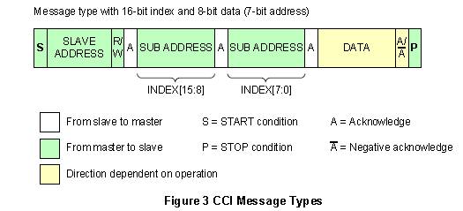
- 支持以下read/write操作The following read/write operations are supported：

    - 从任意位置读取单个数据（Single Read from Random location）
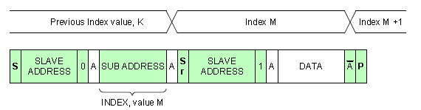.
    - 从当前位置读取单个数据（Single Read from the Current Location）
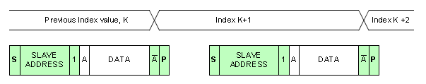
    - 从任意位置读取连续数据（Sequential Read Starting from a Random Location）
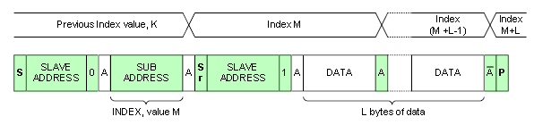
    - 从当前位置读取连续数据（Sequential Read Starting from the current location）
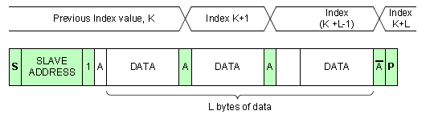
    - 从任意位置写入单个数据（Single write to a random location）
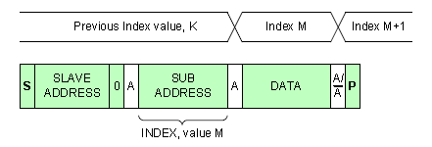
    - 从任意位置写入连续数据（Sequential write to a random location）
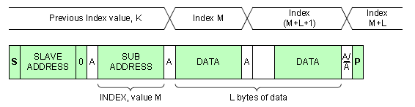
- 支持多字节寄存器操作，遵从CCI协议Supports multi-byte register operation and complies with CCI protocol。
- Multi-byte只支持2，4这两种
Multi-byte supports only 2 and 4
- 对齐：Multi-byte如果是2byte，地址必须以2byte对齐，如果是4byte为4byte对齐，8byte为8byte对齐。
Alignment: multi-byte If the value is 2 bytes, the address must be aligned with 2 bytes. If the value is 4 bytes, the address must be aligned with 4 bytes. If the value is 8 bytes, the address must be aligned with 8 bytes.
- 每种multi-byte分配在不同的地址段。
Each multi-byte is assigned to a different address segment.
- multi-byte register不支持部分访问。
multi-byte registers do not support partial access.
- data为MSB first，高字节在前，低字节在后。
data is MSB first, with high bytes first and low bytes last.
- multi-byte register access必须做好同步。
multi-byte Register Access must synchronize data.

2. 开始出图:preview_start
参数说明如下表：
path | src | width | height | fps | mode
数据通路  Data path  Stream0/Stream1 | 探测器数据Sensor data /  固定图案数据Fixed pattern data | 图像宽度Image width | 图像高度Image height | 帧率Frame rate | 输出模式  其中DVP为0  The output mode  Where DVP is 0

3. 停止出图:preview_stop
参数path，与preview_start的参数相对应
The path corresponds to the preview_start

4. 特殊命令接口Special command interface
可参考libirSDK.chm和《Tiny1C模组SDK接口V1.2.xlsx》表格，因SDK的产品兼容性考虑，部分接口并非本产品使用，有些接口存在冗余。用户只需使用《Tiny1C模组SDK接口V1.2.xlsx》表格中的指令即可，表格中未列出的指令请不要使用，尤其是擦写flash的函数。下表重点介绍几个常用的命令接口。
Refer to libirSDK.chm and “Tiny1C模组SDK接口说明Interface Description1.2”. Due to the compatibility of SDK products, some interfaces are not used by this product, and some interfaces are redundant. Users only need to use the instructions in the table“Tiny1C模组SDK接口说明Interface Description1.2”, please do not use the instructions not listed in the table, especially the function to erase and write the flash. The following table focuses on several common command interfaces.
函数接口Function | 功能Description | 说明Notes
y16_preview_start | 用于切换出图数据源  (可切换成温度数据输出)  Use to switch out the graph data source(Can be switched to temperature data output) | 仅适用于256*192分辨率下使用  256*192 Only
y16_preview_stop | 用于结束数据源切换  Used to end a data source switch | 仅适用于256*192分辨率下使用  256*192 Only
dpc_auto_calibration | 用于模组内置自动盲元标定  Auto Dead Pixel correction | 设定时间越长，效果越好  By increasing the setting time, the effect can be improved
rmcover_auto_calc | 用于图像锅盖标定  Lid pattern noise correction | 需要等待较长时间，约5s  about 5s
tpd_ktbt_recal_1point | 用于测温二次标定(单点标定)  One-point Secondary calibration | 需要等待较长时间，约10s  about 10s
tpd_ktbt_recal_2point | 用于测温二次标定(两点标定) Two-point Secondary calibration | 需要等待较长时间，约15s  about 15s

说明：对于需要等待较长时间的标定命令，可通过宏I2C_TRANSFER_WAIT_TIME_MS来设置等待时间。
Note: For calibration commands that need to wait a long time, the macro I2C_TRANSFER_WAIT_TIME_MS can be used to set the wait time.

5. 其他命令接口Other command interface
可参考libirSDK.chm和《Tiny1C模组SDK接口V1.2.xlsx》表格。
Refer to libirSDK.chm and “Tiny1C模组SDK接口说明Interface Description1.2”
SDK开发包中的VDCMD目录即为相关用户参数读写函数接口的抽象和封装，采用注册函数的方式隔离底层的通信接口。方便在不同的平台进行移植，也可扩展和适配其他不同的通信接口，如USB和UART等等。本SDK中未采用DVP接口自带的SCCB接口，而是采用STM32的I2C2接口模块对模组进行命令控制。
其中，falcon_cmd.h中包含了所有的用户函数接口，falcon_cmd.c是所有用户接口的实现，SDK根据芯片的特征将所有读写接口分别划分为short command，standard command和long command三种类型的读写函数，共六种命令抽象接口，在vdcmd.c文件中进行实现，并且再利用这些抽象接口以注册函数的形式调用不同的通用通信接口函数，然后再实现底层函数的适配。用户进行不同平台移植时，只需要将VDCMD文件夹内的文件进行复制后，替换 I2C的底层接口HAL_I2C_Mem_Read/HAL_I2C_Mem_Write即可。命令接口的整体实现框架如下：
The VDCMD directory in the SDK is the abstraction and encapsulation of the user parameter read and write function interface, and uses the registration function to isolate the underlying communication interface. It is convenient for porting on different platforms, and can also be extended and adapted to other different communication interfaces, such as USB and UART.
Falcon_cmd. h contains all user function interfaces, falcon_cmd.c is the realization of all user interfaces, and SDK divides all read and write interfaces into short commands according to the characteristics of chips. Standard command and long Command three types of reading and writing functions, a total of six command abstract interface, in vdcmd.c file to implement, and use these abstract interface in the form of registration function to call different general communication interface functions, and then realize the adaptation of the underlying function. When migrating to different platforms, you only need to copy the files in the VDCMD folder and replace the HAL_I2C_Mem_Read/HAL_I2C_Mem_Write interface of I2C. The overall implementation framework of the command interface is as follows:
The VDCMD directory in the SDK is the abstraction and encapsulation of the user parameter read and write function interface, and uses the registration function to isolate the underlying communication interface. It is convenient for porting on different platforms, and can also be extended and adapted to other different communication interfaces, such as USB and UART.
Falcon_cmd. h contains all user function interfaces, falcon_cmd.c is the realization of all user interfaces, and SDK divides all read and write interfaces into short commands according to the characteristics of chips. Standard command and long Command three types of reading and writing functions, a total of six command abstract interface, in vdcmd.c file to implement, and use these abstract interface in the form of registration function to call different general communication interface functions, and then realize the adaptation of the underlying function. When migrating to different platforms, you only need to copy the files in the VDCMD folder and replace the HAL_I2C_Mem_Read/HAL_I2C_Mem_Write interface of I2C. The overall implementation framework of the command interface is as follows:
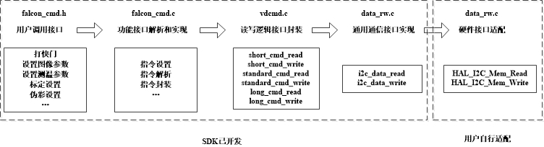

SDK其他功能介绍Other Functions

固件升级功能Firmware Upgrade:
例程中打开UPDATE_FW宏再进行编译即可进行模组的固件升级功能。该例程采用的是用SD卡进行固件升级，移植了一个FATFS文件系统，通过文件系统挂载SD卡，初始化后读取SD卡内的固件文件，然后进行通过I2C接口进行固件数据下载。
主要的升级步骤如下：
To upgrade the firmware of the module, open the UPDATE_FW macro and compile it. This routine uses SD card to upgrade firmware, transplants a FATFS file system, mounts the SD card through the file system, reads the firmware file in the SD card after initialization, and then downloads the firmware data through I2C interface.
The main upgrade steps are as follows
- 挂载SD卡
Mount the SD card
- 动态申请读写缓冲区
Dynamically applying for read/write buffers
- 获取设备状态，如果不是ROM状态则进行切换，直到切换成ROM状态为止
Gets the device state, if not the ROM state, then switches until the ROM state is switched
- 检查flash状态
Checking the Flash Status
- 擦除flash代码区的扇区
Erases sectors in the Flash code area
- 校验flash代码区的扇区
Verifies the sector of the Flash code area
- 循环读取SD卡中的固件数据，写入flash并读出校验
Read the firmware data in the SD card, write to the flash, read and verify
- 完成后写入cache tag
Then write the cache tag
- 复位模组
Reset the module
- 释放读写缓冲区
Release the read/write buffer
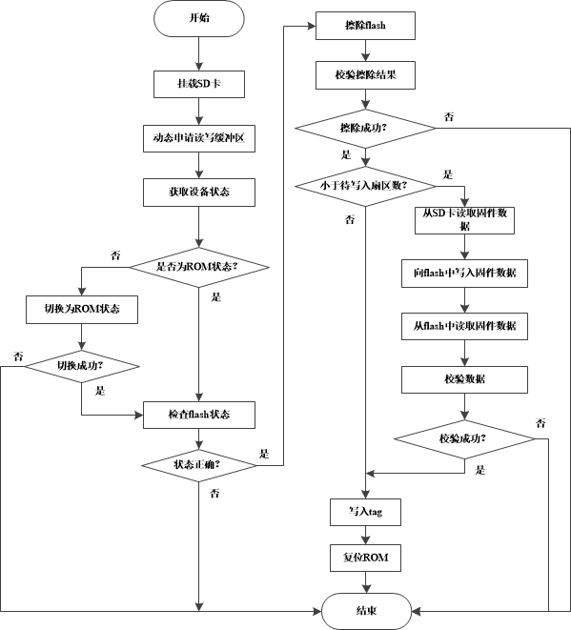
SD卡更新固件说明

盲元标定Dead pixel correction
模组在使用过程中，受到比较严重的机械冲击或静电放电后，有极低的概率出现新增盲元，用户可将新增盲元添加到盲元表中。该功能有多种实现方法：1. 调用固件中的自动标定功能；2. 手动输入新增盲元坐标。详细的使用说明见《用户开发标定》目录下的《盲元标定》。
If a module is hit by a serious mechanical shock or electrostatic discharge (ESD), there is a very low probability that new dead pixels will appear. You can add new dead pixels to the dead pixel table. There are several ways to implement this function: 1. Call the automatic calibration function in firmware; 2. Manually enter the coordinates of the new Dead pixel. For detailed instructions, see Dead pixel correction in the catalogue of "User calibration instructions"

测温二次标定与锅盖标定Secondary calibration& Lid pattern noise correction
非制冷红外热像仪对温度敏感，无论模组出厂测温标定如何精确，当用户将模组集成到整机中后，由于热分布的变化、光学结构的变化（加窗口片等），必然引起一定的测温偏差。因此需要在整机端进行二次标定和锅盖标定。该功能在模组固件中实现，详细的使用说明见《用户开发标定》目录下的《二次标定与锅盖标定》。客户应该先进行锅盖标定再进行测温二次标定。
When the user integrates the module into the whole machine, it will inevitably cause a certain temperature measurement deviation due to the changes of thermal distribution and optical structure (add window, etc.). Therefore, Secondary calibration& Lid pattern noise correction is required at the end of the machine. This function is realized in the module firmware. For detailed instructions, see "Secondary calibration& Lid pattern noise correction" in the directory of "User calibration instructions". The customer should first calibrate the Lid pattern noise and then Secondary calibration.

测温环境变量修正功能Ambient variable correction
红外测温的精度受到很多环境参数的影响，例如距离、环境温度、反射温度、湿度、目标发射率等等。该SDK为用户提供了一种测温修正的方法，可以使测温精度更加接近真实值。详细的修正方案见《用户开发标定》目录下的《环境变量修正》。对于STM32平台而言，SDK的测温修正需要从SD卡读取距离修正表。同时，SDK的工程依赖了一个libirtemp库，该库的源码并不开放。如果客户使用该方法，可以提供厂商相关的编译工具和编译方法，由厂商编译完成后再由客户调用开发。
The temperature measurement of the module is affected by Emissivity, Atmospheric transmissivity, ambient reflection temperature, ambient atmospheric temperature, target distance, etc. The SDK provides users with a correction method, which can make the temperature measurement accuracy closer to the real value. For detailed instructions, see "Ambient variable correction" in the directory of "User calibration instructions". For the STM32 platform, the SDK's temperature correction needs to read the correction table from the SD card. At the same time, the SDK project relies on a libirtemp library, which is not open source. If the customer uses this method, you can provide the compilation tools and methods related to the manufacturer. After the compilation is completed, the customer call this library to develop.

防跌落保护Fall protection
由于红外模组双稳态快门的物理特性，当模组发生某个方向上的跌落或者撞击时，快门会有概率闭合上，导致红外图像异常。因此，模组固件内置防跌落功能，防跌落功能的实现策略大致为：检测图像画面，对画面的均匀性进行统计，如果发现画面输出值的离散程度小于设定的阈值，则固件会通过GPIO发送脉冲强制打开快门。通过set_prop_auto_shutter_params函数的SHUTTER_PROP_PROTECT_SWITCH参数，可以设置该功能的开关。通过SHUTTER_PROTECT_THR_HIGH_GAIN可以设置高增益状态下的阈值，通过SHUTTER_PROTECT_THR_LOW_GAIN可以设置低增益下的阈值。
The shutter blade may open/close abnormally during strong mechanical shock (such as fall), and a monitoring process is designed in the firmware to correct the abnormal shutter switch in time. This feature is called fall protection. The strategy is as follows: detect the image and make statistics on the uniformity of the picture. If the dispersion degree of the picture is less than the set threshold, the firmware will send pulses through GPIO to force the shutter to open. You can switch this function on or off by using the SHUTTER_PROP_PROTECT_SWITCH parameter of the set_prop_auto_shutter_params function. SHUTTER_PROTECT_THR_HIGH_GAIN allows you to set a threshold in the high gain state, and SHUTTER_PROTECT_THR_LOW_GAIN allows you to set a threshold in the low gain state.
图3.快门防跌落保护策略
Figure 3. Shutter fall protection strategy

点线框测温说明Description of point/line/box temperature measurement
本产品模组内置点线框测温功能，可以分别调用falcon_cmd.h库中的tpd_get_point_temp_info、tpd_get_line_temp_info，tpd_get_rect_temp_info来获取模组内的特定的点线框温度信息，也可以调用函数tpd_get_max_min_temp_info函数获取整帧的温度最大/最小值信息。
This product module has built-in temperature measurement function of point, line and box. You can call tpd_get_point_temp_info、tpd_get_line_temp_info，tpd_get_rect_temp_info to get the specific temperature information. You can also call the tpd_get_max_min_temp_info function to obtain maximum/minimum temperature information for the entire frame.

数据格式说明Data Format Description

1.图像数据Image data
图像数据的输出格式为YUV422格式，即YUYV格式。
The output format of image data is YUV422 format, namely YUYV format.

2.温度数据Temperature data
每个像素的温度需要2个byte存储，放在高14位，按照小端存放。如下图。
The temperature data of each pixel needs to be stored in 2 bytes, which are placed in the upper 14 bits and stored as the little end.
低地址 Low address | 高地址 High address
低字节 Low byte | 高字节 high byte
可调用temp_value_converter函数接口将原始温度数据转换成摄氏温度。
The temp_value_converter function interface can be called to convert raw temperature data to Celsius.

图像显示方法Image display method
为了将图像显示出来，可以调用YUV422ToRGB565函数将yuv422数据传输到RGB LCD显示屏进行显示。
To display the image, the YUV422ToRGB565 function can be called to transfer the YUV422 data to the RGB LCD screen for display

